Effective October 4th 2018

**2nd Amendment to ADDENDUM (Nov 6th 2016)**

**Junior Selection Policy – Dated: September 2011**

The Tennis Association of Trinidad and Tobago in consultation with its Jr Selection Committee and its Technical Committeehave created a new Standardized Weighted Selection Matrix as a guide in an attempt to eliminate any perceived subjectivity and potential biasness when selecting the best players to represent Trinidad and Tobago. It must be noted that this selection policy has been in existence for many years and covers many of the bases; however it is the inconsistency in the application of weight/importance to the various selection criteria which create issues with transparency in the selection process. This was the consensus of the parents of player at our consultation session on October 6th 2016. The Matrix system was presented to parents and approved by the Executive on November 5th 2016.

This new Standardized Weighted Selection Matrix takes into consideration the main selection criteria within the Junior Selection policyand allocates points for each. The main criteria considered include:

1. ITF Rakings
2. COTECC Rankings
3. Local Rankings (consisting of local tournaments only), taken over 12 month period
   1. Base Age Group Ranking
   2. Next Upper Age Group Ranking
4. Fitness – YOYO Beep Test
5. ITN

This will be used to shortlist the top 6-8 players in the U14 & U16 categories who would be eligible to participate in final team selection trials.

Fitness tests and ITN must be taken on the date prescribed.

The final team selection trials will be a round robin to select the team and a reserve

It should be noted that:

* players who have not participated in the National Junior Championships without receiving exemption will not be in line for selection
* Players on disciplinary suspension at the time of selection would not be eligible for selection
* Players not holding a valid TTO passport at the time of selection will not be eligible for selection
* Players who are not in the National Programme (suspension or otherwise) at the time of selection will not be eligible for selection unless granted special approval by TennisTT Executive.

It should be noted as well that in cases where players may be eligible to represent TTO at two age groups, it is incumbent upon the players to manage their affairs accordingly in order to be selected to represent TTO in one or both categories if this is what they desire. Unless given special approval by TennisTT, all players are required to abide by the rules for placement onto the National Team.

The system is standardized for each age category as the each selection criteria will be weighted differently for each category.



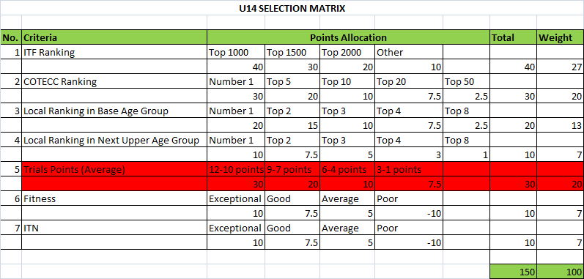

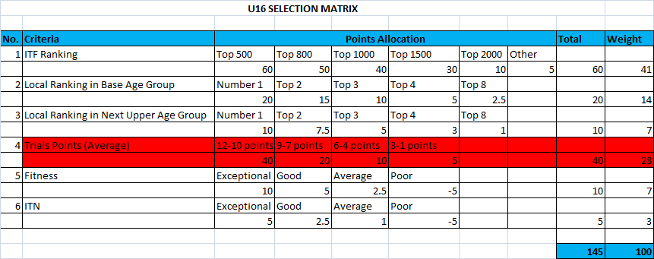

**Foreign Based Players**

Foreign based players (those players with a valid TTO Passport who live and go to school outside of Trinidad and Tobago) must participate in the National Junior Championships in order to be eligible for selection into the national Programme and possible National Teams unless granted an exemption by the Executive. Once included in the National Junior Programme, foreign based players will be required to fulfil the following requirements in order to secure a spot on the trials shortlist:

1. Player must submit results of tournaments played in their how country or otherwise. The level of the tournaments submitted will also be a deciding factor.
2. Player must avail himself/herself to participate in a fitness test and the ITN while in Trinidad except if otherwise approved by TennisTT.

Once shortlisted for trials, foreign based players must avail themselves to participate in the final selection trials.

*This policy will be reviewed on September 1st 2019*