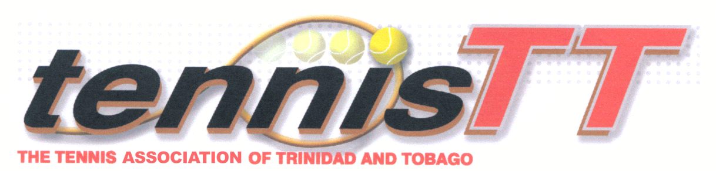
RBC TOBAGO JUNIOR TENNIS

CHAMPIONSHIP 2022
SHAW PARK TENNIS COURTS, SCARBOROUGH, TOBAGO MONDAY 25TH JULY – SATURDAY 30TH JULY 2022.

ENTRY FORM
NAME: …………………………………………………………….……………….………..……..
ADDRESS: …………………………………………………………………..……………..……...
DATE OF BIRTH: ……………….……….. TELEPHONE CONTACT: ……….………..…..
E-Mail:……………. ……….…………………… T-Shirt Size: 14, 16, S, M, L, XL
SIGNATURE: …………………………………………….

Singles:-

Boys U 10 [ ] Girls U 10 [ ] Boys U 16 [ ] Girls U 16 [ ] GRADE II U12 [ ]

Boys U 12 [ ] Girls U 12 [ ] Boys U 18 [ ] Girls U 18 [ ]
Boys U 14 [ ] Girls U 14 [ ]
Doubles:-
Boys U10 [ ] Girls U10 [ ] Boys U14 [ ] Girls U14 [ ] Boys U18 ( ) Girls U18 ( )
Boys U12 [ ] Girls U12 [ ] Boys U16 [ ] Girls U16 [ ]
RED BALL U 10 [ ]
My partner is ……………………………………………………………………...............................
Entry Forms available from any member of the Tournament Committee and TATT Office or website www.tennistt.info. Completed entry forms should be returned by Wednesday 20th July 2022, (4:00PM) to any member of the Tournament Committee, TATT Office or emailed to crusoeisletennissecretary@gmail.com.

Entry Fee: Juniors TT$120.00 [ ] *TATT Registration Fee TT$65.00 [ ] *if not already paid for 2022.
Red Ball and Grade II players $60 [ ]

Total Paid ............................ Date.......................... Collected by.......................................

