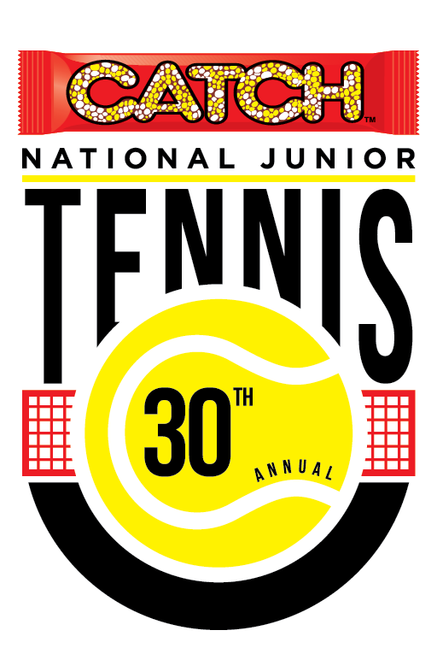

Tennis

Tennis Association of Trinidad and Tobago
National Racquet Centre ,
Orange Grove Rd., Tacarigua
Trinidad, W.I. Tel.: (868) 681-0051
E-mail: tennistt2.tatt@gmail.com

CATCH NATIONAL JUNIOR CHAMPIONSHIPS 2018

PROSPECTUS

Tournament Committee
Tournament Director Mr. Dave A. Patrick (751-6129) Tournament Secretary Ms. Ann Timothy-Tozer
Tournament Referee Mr. Edwin Chu For Assistant Referee Mr. Chester Dalrymple
Treasurer Mr. Joe Ward Committee member Ms. Rhonda Mohammed

Intent: The National Junior Championship serves as the showcase for Junior Tennis in Trinidad & Tobago highlighting our best players while introducing new players to tennis.

Events
Transitional:
Red Ball Boys & Girls: 8 & Under (born between 1 Jan 2010 - 31 Dec 2012)
Red Ball Boys & Girls 10 & Under (born between 1 Jan 2008 - 31 Dec 2012)
Orange Ball Boys & Girls 12 & Under (born between 1 Jan 2006 - 31 Dec 2010)
Regular Events: Boys’ & Girls’ 10 & Under (born between 1 Jan 2008 - 31 Dec 2012)
Boys’ & Girls’ 12 & Under (born between 1 Jan 2006 - 31 Dec 2010)
Boys’ & Girls’ 14 & Under (born between 1 Jan 2004 -31 Dec 2007)
Boys’ & Girls’ 16 & Under (born between 1 Jan 2002- 31 Dec 2005)
Boys’ & Girls’ 18 & Under (born between 1 Jan 2000 - 31 Dec 2005)
Boys’ & Girls’ 21 & Under (born between 1 Jan 1997 – 31 Dec 2001)
Boys’ Doubles 10 & Under; 12 & Under; 14 & Under; 18 & Under; 21 & Under
Girls’ Doubles 10 & Under; 12 & Under; 14 & Under; 18 & Under; 21 & Under
Mixed Doubles 10 & Under; 12 & Under; 14 & Under; 18 & Under; 21 & Under
(players please note that no points will be allocated for Mx. Dou.)

DOUBLES’ SIGN-IN CLOSES SUNDAY 1st APRIL, 12 noon, at Referee’s office (partners must be present).

RULES & REGULATIONS

1. ENTRY.
- Entry Fee. Regular, $100 per player (covers both singles’ and doubles’ events); and $50 for Transition Players (singles only; no doubles). There is a late Entry Fee of $200 for entries after the closing date.
TATT’s registration of $65 for 2018 is required for all players. However, Transition Players are exempted from paying TATT registration fees.
- Availability of Forms: The Tennis Association (TATT) office, The Racquet Center, Tacarigua.
Forms can also be downloaded from the website, http://tennistt.info
(c) Submission of Entries: Entries will only be valid when submitted upon payment and sign-in at the tournament site. Tenders include Dexter MAHASE (south), David DENOON (Tobago), Dave PATRICK and Keshan MOONASAR (east) and the Tennis Office at the National Racquet Centre.
(d) Eligibility: Age Eligibility. For purposes of this Rule, see page 1. Proof of age must be submitted; players entering inappropriate age group will be corrected. Entry is restricted to citizens of Trinidad & Tobago.
Transition Players: Open for beginners: these players are not allowed to play in the Regular events.
Regular Players are allowed to enter two (2) Doubles’ events (Mixed and another) AND ONE (1) Singles’ event; ALL players are allowed a maximum of three (3) events.
The first four ranked players in the categories, 12’s, 14’s, 16’s, and 18’s are allowed to play “up”; in addition to playing in their “based age group”. So that these players will be allowed to play TWO singles and ONE doubles. Ranking will be based on the most recent published TATT Ranking. Consequently, other than appropriate rest periods, no special privileges will be given to these players. Such players may be asked to play up to four matches a day (2 singles and 2 doubles).
The Committee reserves the right to exempt a player from his/her ‘based age group’ to a higher age group.
Doubles entries will close at 12:00 noon on Sunday, 1st April 2018, on site. Both players must sign in, together. Players may play “up”; e.g., 12’s can play 14’s Doubles. The 16’s, 18’s & 21’s may combine for the Mixed Doubles.
To be eligible for prizes, a player must have won a match in the Main draw, and, players retiring from a match must provide a valid medical certificate that will allow him/her to play in other events.

2. Closing date/ Draw. Entries close on Monday 26th March 2018 at 4:00 pm., at TATT’s office, The Racquet Center, Tacarigua. Draws will be done on Friday 30th March 2018, at the Racquet Center.
The tournament starts on Saturday 31st March 2018 at 9.00 am and ends on Thursday 5th April 2018.
Entries for the Transition tournament close on Friday 30th March, at 5:00 pm., and will be played on Wednesday 4th April at 9:00 am.
CATCH will be celebrating 30 years of sponsorship, and, as part of this celebration, will be hosting “Fun-related” activities and giveaways on Friday 30th March, starting at 12 noon. ALL are welcome.
Players’ Sign-in follows between 3-5 pm.
ALL PLAYERS ARE REQUIRED TO SIGN-IN on Friday 30th March, between 3:00-5:00 pm., at the Racquet Center. Players who have not settled their fees at the sign-in, will not be put in the draw.
T-shirt distribution will be at 5:00 pm. The Opening ceremony follows at 5:15pm.
OPENING CEREMONY ATTENDANCE IS MANDATORY .
3. Match Format.
(i) Events with an entry of five (5) or less may be played in a Round-robin format.
(ii) U10, U12 & U14 categories will play round-robin (RR) with the best of three (3) short sets.
SHORT SETS. The first player/team who wins four games, with No-Ad scoring, wins that set, provided there is a margin of two games over the opponent(s). If the score reaches three (3) games all, a tie-break game shall be played.
SHORT SET TIE-BREAK. The first player/team to win five points wins the “Game” and “Set”, with a deciding point if the score reaches four all. During a tie-break game, players shall change ends after the first point and thereafter after every four points.
Two players from each group will progress to a Main Draw (knock-out), where the Short Set format continues.
The U14’s will follow COTECC’s format. RR short sets with a TB at 4-4; with Advantage scoring. A Main Draw Knock-out with 3 TB sets and Advantage scoring.
(iii) ALL U14, U16, U18 & U21 Main Draw matches will be the Best of three regular (i.e. with ‘Advantage’ scoring) sets with a Tie-break at 6-6.
(iv) 10’s & 12’s DOUBLES will be 2 Short Sets, with No-Ad scoring, and a Match Tie-Break (7 point, a team who first wins 7 points with a 2 point margin), in place of a 3rd set. ALL other Doubles will be two (2) Tie-Break sets with no ad-Scoring, and a Match Tie-break (10 point), in place of a third set. In Mixed Doubles, at deuce (40-40), the server shall serve to the same gender as him/herself.
(v) “NO LET” RULE. This is play without the service let in Rule 22.a, whereby a serve that touches the net, strap or band and is otherwise good. This APPLIES in BOTH SINGLES and DOUBLES.
When playing doubles, employing Short Sets only, either player on the receiving team is permitted to return a serve that touches the net, strap or band and is otherwise good lands within the correct service box. Consequently, only in the 10’s & 12’s, will the receiver’s partner will be allowed this.
(vi) Play shall continue under lights where necessary.
(vii) Balls. For the U10’s, Green Dot balls will be used; ALL other events shall use PENN balls.
(viii) Players may be required to play as many as 3 matches per day.
(ix) Transition events. Subject to entry response, may be the first to 7 or, 11 points.
In case of severe weather conditions, the tournament committee may use alternate scoring methods, as approved in the 2018 Rules of Tennis.

4. Site Details. All events will be played at the Racquet Center, Tacarigua.
5. This Competition shall take place in accordance with these Regulations, the Junior Circuit Code of Conduct, and the 2018 ITF Rules of Tennis, each of which may be amended from time to time.
6. In submitting an entry to this tournament, a player automatically undertakes to commit him/herself to abide by, and be bound by, the above Rules and Regulations. Furthermore, all claims of any kind, nature and description are waived.
7. The Committee reserves the right to amend, repeal, or otherwise modify, in whole, or in part, the
above Rules and Regulations.

DRESS CODE
Players shall present themselves for play in a professional manner. Clean and acceptable tennis attire shall be worn.
Unacceptable Attire: Sweatshirts, gym shorts, dress shirts, basketball attire, beachwear, T-shirts (particularly with writing!) or any other inappropriate attire shall not be worn during a match.
CATCH T-SHIRTS WILL BE ACCEPTABLE WEAR FOR PLAY, in this tournament.
PARTICIPATION IN THIS TOURNAMENT IS MANDATORY FOR PLAYERS WHO ARE INTERESTED IN BEING CONSIDERED FOR NATIONAL SELECTION.

